

**Banner 9 Icon Glossary**

|  |  |  |  |
| --- | --- | --- | --- |
| **Landing Page Icon Overview** | | | |
|  | **Name** | **Icon** | **Description** |
| 1 | Toggle Menu  Icon |  | The Toggle Menu icon is located in the upper left corner. Click on this icon to expand and collapse your left-hand navigation menu. |
| 2 | Dashboard/Home  Icon |  | Returns user to Welcome screen. |
| 3 | Applications  Icon |  | Opens Banner menus |
| 4 | Search Icon |  | This icon allows you to search from the left-hand navigation window. You can enter the descriptive name of the form or the Banner acronym for the form. |
| 5 | Recently Opened Icon |  | Recently Opened icon displays a current count of forms opened during your logged in session. Click the icon for the list and select a form to re-access it. |
| 6 | Help Icon |  | The Help Icon will give you the option to access Page Help or Application Navigator Keyboard Shortcuts. If you select Page Help while on a form, it will give you detailed information about the form you are on. Keyboard Shortcuts gives you the shortcuts for the Welcome screen. |
| 7 | Favorites |  | Set-up your Banner Favorites by clicking on the star from the search bar. |
| 8 | Sign Out Icon |  | **ALWAYS USE** the Sign Out Icon when closing Banner. Do not just close your browser window, that does not sign you out of Banner. |
| 9 | Banner User Information Icon |  | Displays the Banner username of the person logged into this session. |
| 10 | Search |  | Users can begin typing a form name, partial form name, or the descriptive form name and a list will appear of available forms. |
| **See screenshot on next page for location of all icons on the Welcome Screen.** | | | |

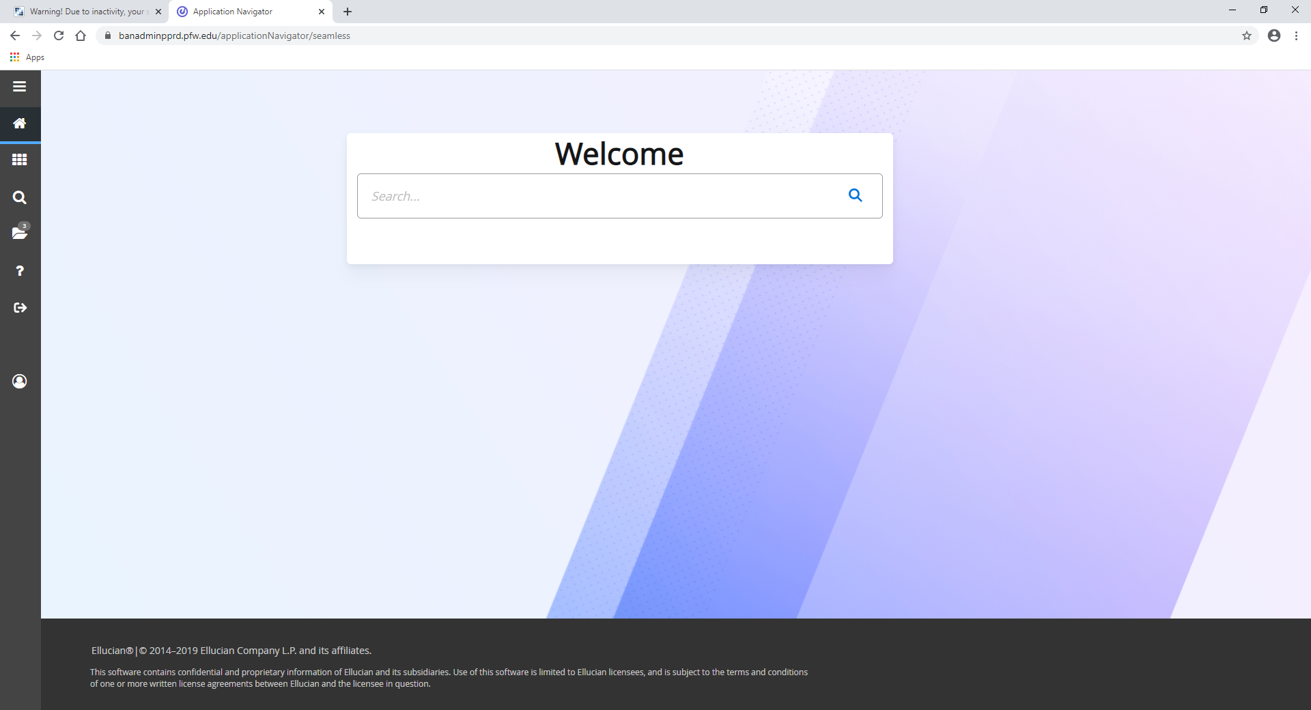



Banner 9 Icon Glossary

|  |  |  |
| --- | --- | --- |
| Form Navigation Icon Overview | | |
| Task | Icon | Description |
| Form Close Icon |  | Closes your current form & returns you to the landing page. |
| Add Icon |  | Used for adding Extender documentation (not used at PFW) |
| Retrieve Icon |  | Used for adding Extender documentation (not used at PFW) |
| Related Menu |  | Used to display a list of forms that are related to the current form and may be accessed from this form |
| Tools Menu |  | Tools Menu includes Options and Actions including Refresh, Export, Print, Clear Record, Clear Data, Item Properties, Display Id Image, Exit, Quickflows, and other options controlled by the page. |
| Go |  | Use the Go button to advance (roll in to) the body of the Banner form |
| Save |  | Use the Save button to save changes on the form. The Save button is located on the bottom right side of the form. |
| Next Block/Previous Block |  | Use the Next Block (arrow down) button to navigate to the next block of data. Use the Previous Section button (arrow up) to navigate to the previous section. Buttons are located at the bottom left of each form. |
| Start Over |  | Use the Start Over button to return to the beginning of the form you are currently on. |

|  |  |  |
| --- | --- | --- |
| Selection Icon Overview | | |
| Insert |  | Insert records within the block |
| Delete |  | Delete records within the block |
| Copy |  | Copy records in the block |
| More information |  | Opens up the Supplemental Data form |
| Filter |  | Filter records in this block |
| **See screenshot on the next page to see locations of all these icons.** | | |

**See screenshot on next page for location of all icons on the Welcome Screen.**

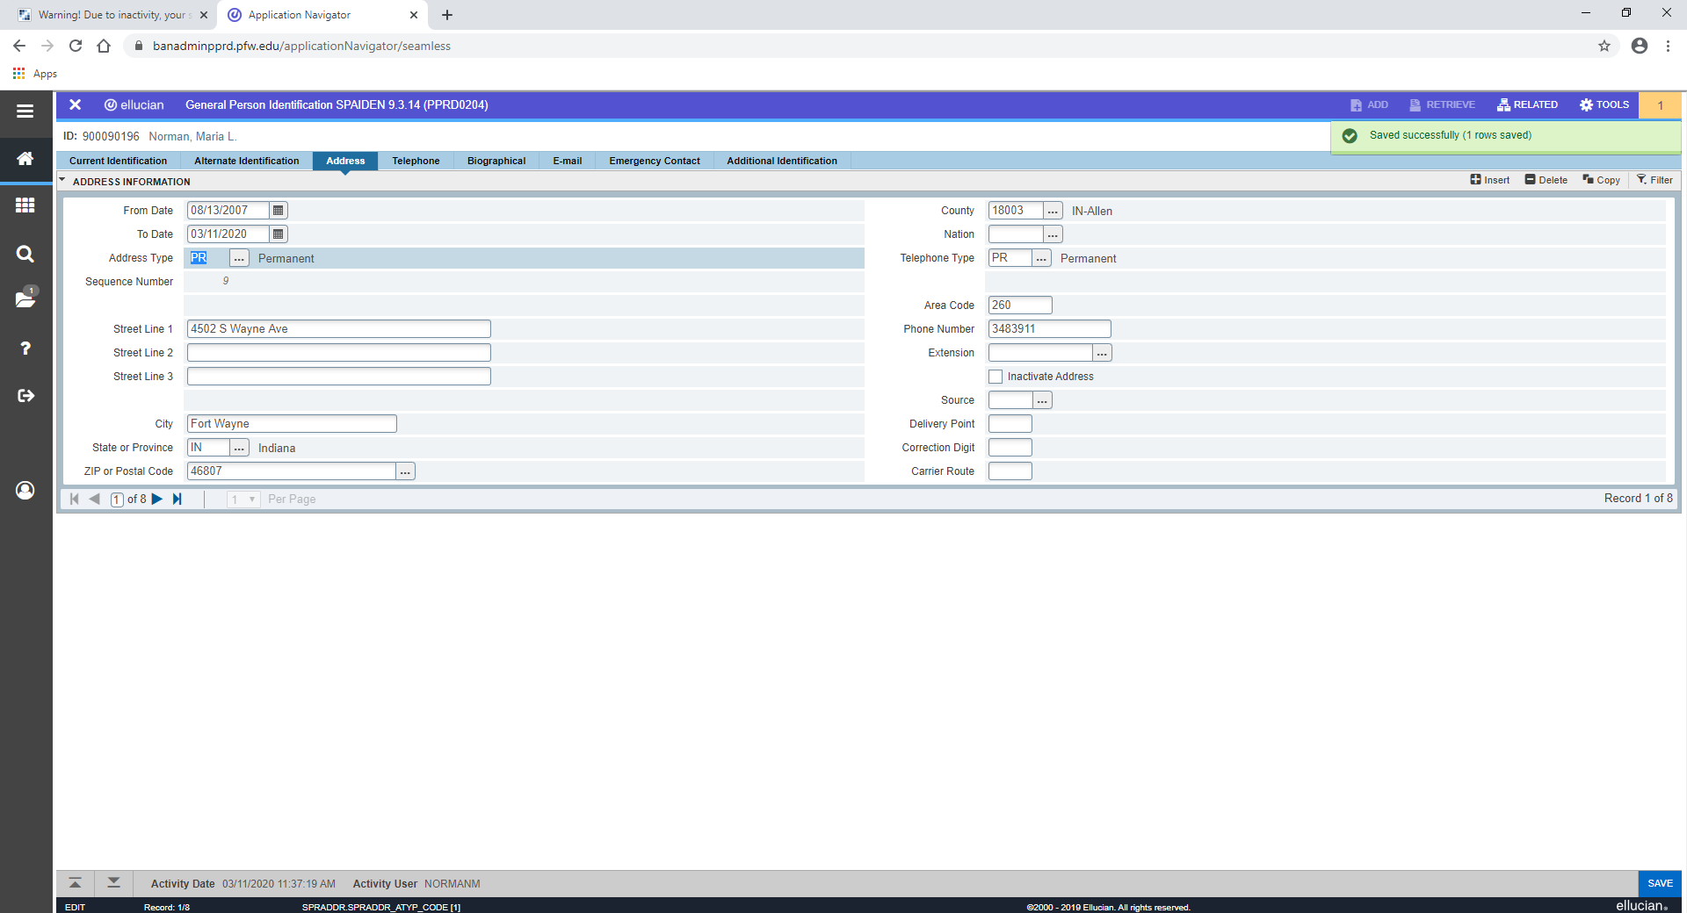

Banner Notifications

The notification center displays only when there are one of more alerts, as indicated by the number. You can click in the box to close the alert message. There are four alert levels that display the following types of information:

